CSE 554: Systems for Machine Learning – Assignment 1
In this assignment, you will practice GPU programming using PyTorch, Triton, and CUDA, along with profiling techniques. The assignment consists of three parts: SiLU, RMS Norm, and Host-GPU Communication. Your submission will be in the form of a .zip file uploaded to Canvas and must include a short report with answers to the following questions (.pdf), code, and profiling results. For performance-related questions, you will receive 0 points if your kernel is incorrect. If your kernel is correct, your score will be determined linearly based on its performance. You will receive a full grade if your kernel meets or exceeds the performance standard, which is around 60-70% performance of our reference kernels.
The template code can be found at https://github.com/efeslab/cse554-winter-2026
FAQ:
- Profiling:
  - Memory accesses are defined as the number of loads and stores to the GPU global memory (HBM) needed to carry out the computation. We expect you to theoretically infer the minimum number of memory accesses needed from the input and output tensor shape, datatype, and the operation being performed. This excludes any memcpy (host-to-device, device-to-host, device-to-device) operations.
  - To compute memory bandwidth utilisation, determine the minimum number of memory accesses needed for the computation and divide it by total execution time. If your implementation calls multiple kernels to run the computation, the execution time should include the total time from the first kernel’s launch until the last kernel’s execution. This would account for the kernel launch overhead (and overhead of any additional memory copies / allocations needed).
  - For accurate kernel execution time measurements use torch.cuda.Event() and torch.cuda.synchronize().
  - Reference kernels are our own implementation which we use as a baseline for grading. You do not need to match the reference kernel's performance exactly. The target bandwidths provided in each part are intended to be guidelines to indicate what an optimized implementation can achieve. Achieving performance in the expected range (that is, close to the target bandwidth) along with correctness is sufficient for credit.
  - Since CSE servers are being shared among groups, it is possible that the GPU resources are contended, leading to inaccurate measurements. Make sure to check nvidia-smi and make adjustments to CUDA_VISIBLE_DEVICES as needed to use the right GPUs assigned to your group.
  - For torch profiler, collecting profiles from the last cycle should be sufficient.
- Correctness:
  - To determine kernel’s correctness, measure the difference between the expected matrix / vector with the output from your implemented kernel. Aim for an accuracy of < 1e-3 ATOL.
- Design choice:
  - You are free to implement the required functionality (ex, SiLU, RMSNorm, memcpy) using any kernel design approach as long as the implementation is correct. For example, you might implement RMSNorm using two separate kernels that you call sequentially or implement a fused single kernel design using the required synchronization primitives. That being said, the choice of design can impact performance and it is encouraged to think about these trade-offs and optimise for higher performance if possible.
- RMSNorm:
  - For this assignment, it is expected to implement the row-wise RMSNorm variant. The RMS is computed independently for each row, and each row is normalized using its own RMS value. The version of RMSNorm expected has also been discussed in the lecture.

Section 1: Implementing the Sigmoid Linear Unit (SiLU)
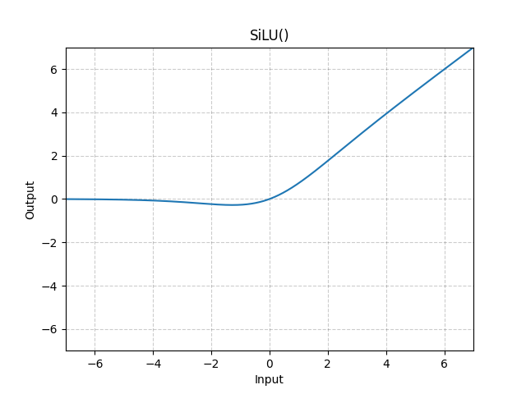
Image source: https://pytorch.org/docs/stable/generated/torch.nn.SiLU.html

Q1. 1 + 1 points
- What are the use cases of SiLU in LLMs?
- What is the mathematical formula for the SiLU function?

Q2. 2 + 4 + 2 points
- In PyTorch, without using nn.SiLU or nn.Sigmoid, implement the SiLU function using basic tensor operations for a matrix of shape (8192, 8192) in silu/silu_torch.py.
- Use Torch Profiler and NVIDIA Nsight Systems to profile the execution.
  - Include screenshots in the report.
Submit the profiling outputs as:
    - torch_silu.json (Torch Profiler)
    - torch_silu.nsys-rep (Nsight Systems)
- Analyze and answer the following:
  - What kernels are being launched?
  - What is the minimum number (discount repetition and intermediate results) of memory accesses necessary (read and write) to accomplish the task?
  - What is the bandwidth usage (minimum number of necessary memory accesses / total execution time) of SILU?

Q3. 8 + 2 points
- Implement the SiLU function using Triton in silu/silu_triton_kernel.py and test your kernel in silu/silu_triton_test.py.
- Time the custom Triton kernel and report the timing and bandwidth.

Q4. 8 + 2 + 10 points
- Implement the SiLU function using CUDA in silu/CUDA/silu.cu. Test your kernel in silu/CUDA/main.cu.
- Time the kernel and compute the bandwidth utilization. Use NVIDIA Nsight Compute (ncu) to analyze your CUDA kernel. Include the report cuda_silu.ncu-rep in your submission.
- Optimize the kernel to achieve bandwidth utilization > 500 GB/s.

Section 2: Implementing RMS Norm

Q1. 1 + 1 + 1 points
- What is the RMS Norm?
- What is RMSNorm used for in LLMs?
- Provide the formula for RMS Norm.

Q2. 10 + 10 points
- Implement a CUDA kernel for RMS Norm for a matrix of shape (8192, 8192) in rms_norm/matrix/rms_norm_matrix.cu, write a test in rms_norm/matrix/main.cu. Time the kernel and compute the bandwidth utilization
- Optimize it to achieve bandwidth utilization > 300 GB/s (attach rms_norm_matrix.ncu-rep).

Q3. 10 + 10 points
- Implement a CUDA kernel for RMS Norm for a vector of shape (1, 1024 × 1024) in rms_norm/vector/rms_norm_vector.cu, write a test in rms_norm/vector/main.cu. Time the kernel and compute the bandwidth utilization
- Optimize this kernel as well to achieve bandwidth utilization > 200 GB/s (attach rms_norm_vector.ncu-rep).

Q4. 2 points
- Compare the thread block assignment for kernels implemented for (8192, 8192) and (1, 1024 × 1024). What are the thread block assignment differences, and why were these changes necessary?

Section 3: Host–GPU Memory Copy

Q1. 2 + 2 + 1 points
- Measure the memory transfer speed:
  - Host-to-GPU and GPU-to-Host
For data sizes of 2^0 to 2^20 bytes for each power of 2.
  - Use C++
- Plot a bandwidth vs. transfer size curve and include it in your report. Plot plot two separate curves for Host-to-GPU and GPU-to-Host.
- What is the peak transfer speed observed?

Q2. 2 + 2 points
- What is pinned memory in the context of NVIDIA GPUs' memory allocations?
- How does it impact the performance of memory transfers between the CPU and GPU? Add a pinned memory curve in the figure for Q1 (Section 3).

Q3. 3 + 3 points
- Assume a matrix (with a dtype of float) of shape (8192, 65536) is on the CPU in row-major order. Implement an efficient C++ host-to-GPU communication routine in host_GPU/copy_first_column.cu to:
  - Copy only the first column of each row to the GPU. Assume that the destination buffer on the GPU is a row vector of size 8192.
  - Optimize the transfer to ensure the total time is under 150 μs (include copy.nsys-rep).

